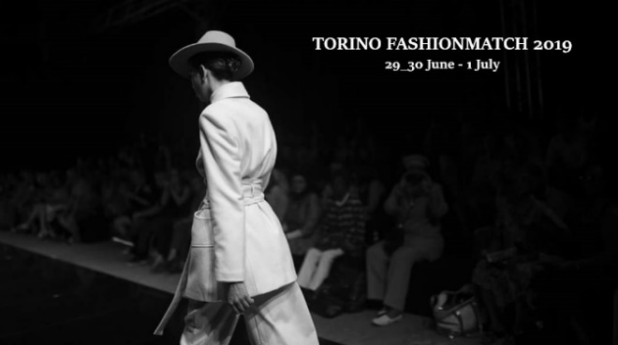 | Programme  Torino Fashion Match 2019
Location:
Palazzo della Luce Building, Via Bertola 40, Turin

Saturday, 29 June 2019
h. 09:00 am -1:00: EEN B2B Session I
h. 1:00 pm – 2:00 Free Lunch

h. 2:.00 pm - 5:30: WORKSHOP I :
- Circular Economy and Sustainability in the Fashion System
- European Case studies on Circular Economy in Fashion and Textile

Sunday 30 June 2019
h. 09:00 am–1:00: EEN B2B Session II
h. 1:00 pm – 2:00 Free Lunch

h. 2:00 pm-5:30: WORKSHOP II:
- Innovate and Digitalize the Fashion System
- The Fashion-Technology Trend

Monday 01 July 2019
h. 09:00 am–1:00: EEN B2B Session II
h. 1:00 pm – 2:00 Free Lunch

h. 2:00 pm-5:30: WORKSHOP III:
- Going International and european funding supports
- Access to finance and Woman Entrepreneurship

29 June 2019
Circular Economy and Sustainability in the Fashion System

h. 14:00 -14:15 Welcome
____________________________________________________________________________________________________________

h. 14:15 -15:00
Title:
Ms. Marina Spadafora
CEO and Founder of Fashion Revolution Italy
____________________________________________________________________________________________________________

h. 15:00 – 15:30
Mr. Corrado Carbonato
Politecnico di Torino Dip. Design

____________________________________________________________________________________________________________

h. 15:30 – 16:00
Title
Ms. IED, Design European Institute (Turin- Italy)
____________________________________________________________________________________________________________

h. 16:00 – 16:30
Sustainability in the Fashion Industry
Mr. Danny Casimir
Founder and CEO at SPLEXS International Trade

European Case studies on Circular Economy in Fashion and Textile

h. 16.30 – 17.00

- Anaïs Renaud (UK)
Ms. Anais Kelly, Founder and Owner at Anaïs Renaud

- Back to Eco (Spain)
Ms. Nuria Nubiola, Ceo at Back to Eco

- Vintage for a cause (Portugal)
Ms. Helena Antonia Silva, Founder & General Director at Vintage for a Cause
- Atlantic Leather (Iceland) tbc
Mr. Sigurlaug Vordís Eysteinsdóttir, Sales Manager at Atlantic Lather

End of work

30 June 2019
Innovate and Digitalize the Fashion System
The Fashion-Technology Trend

h. 13:50 -14:00 Welcome
____________________________________________________________________________________________________________

h. 14:00 -14:30
Innovation Management in a Digital Economy
Mr. Marco Gorini
Italian Expert delegate at ISO Technical Committiee on Innovation Management
____________________________________________________________________________________________________________

h. 14:30 – 14:45
Innovation in Fashion Trade
Mr. Danny Casimir
Founder and CEO at SPLEXS International Trade
______________________________________________________________________________________________________

h. 14:45 – 15:15
Social Media and Digital Marketing in Fashion System
Ms. Nour El-Mohri
Founder of Taam Media
____________________________________________________________________________________________________________

h. 15:15 – 15:45
How to create an Innovative Fashion brand: Actually, tricks and tips !
Ms. Bali Lawal
CEO and Founder A Coded World, fashion brand
____________________________________________________________________________________________________________

Innovative european E-commerce platforms _ case studies

h. 15:45 – 16:00
E-Biz-4.0
Mr. Enrique Montiel
Coordinador eBIZ 4.0 Project
____________________________________________________________________________________________

The Fashion Tech Trend

Technology connected Fashion
Ms. Tanya James MBA
Curator at Fashion Tech Week NY

End of work

1 July 2019
Going International and european funding supports
Access to finance and Woman Entrepreneurship

h. 14:00 -14:15 Welcome
____________________________________________________________________________________________________________

h. 14:15 – 14:30
ETP (European Textile Platform) (tbc)
http://www.textile-platform.eu/
____________________________________________________________________________________________________________

h. 14:30 – 14.45
Innovation Network for Europe: Define-Network for Fashion-Tech
Ms. Chiara di Ludovico
Project Officer, Politecnico of Milan (lead partner of the project)
____________________________________________________________________________________________________________

h. 14:45 – 15:15
How to find technology partners and international business partners for the fashion industry
Presentation of 2 european project related to creative industry: Worth Project and Re-FREAM
Ms. Korina Molla
International Project Manager at AITEX - Textile Research Institute
____________________________________________________________________________________________________________

h. 15:15 – 15:45
IPR in fashion_Focus Latin America
Latin America IPR SME HELPDESK
____________________________________________________________________________________________________________

h. 15:45 – 16.15
Title: Access to finance in the fashion system - European support -
Ms. Raffaella Bruzzone
Chair of the Thematic point Access to Finance, Geneva Chamber of commerce Enterprise Europe Network Partner

Access to finance and Woman Entrepreneurship

____________________________________________________________________________________________________________

h. 16:15 – 16:30
Sector Group Woman Entrepreneurship (Enterprise Euorope Network)
Ms. Sanja Popović Pantić
Chairperson of Sector Group Woman Entrepreneurship (EEN)
__________________________________________________________________________________________________________

h. 16:30 – 16:45
FACTS, Fashion Apparel Cluster Serbia
Ms. Afrodita Bajic
President of Assembly of Facts
____________________________________________________________________________________________________________

Woman Entrepreneurship_case study

16: 45 – 17:00
AMC Mode Collection (Serbia)
Ms. Marijana Matic
Marketing manager of AMC Afrodite Mode Collection

End of work

